Shabbos Stories for
Parshas tetzaveh 5779
Volume 10, Issue 27 11 Adar Rishon/ February 16, 2019
Printed L’illuy nishmas Nechama bas R’ Noach, a”h

For a free subscription, please forward your request to keren18@juno.com

The Rabbi and the Governor

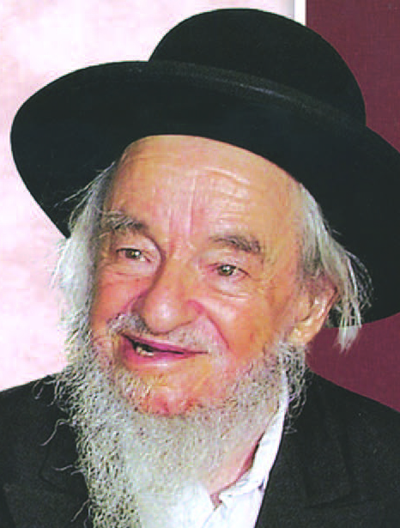
Rav Yaakov Galinsky

HaRav Yaakov Galinsky, Zt”l, brings the following story with HaRav Yosef Feimer, Zt”l, the Rav of Slutsk. The governor of Slutsk [a non-Jew] approached him, as the Rav of the city, and asked “HaRav Feimer, Why do you Jews glorify yourselves as the Chosen People -- how are you different than all of the other nations?”
The Rav responded: “What do you mean--how are we different?--with everything--we are especially circumspect in Kashrus and what we eat--being careful to check even our vegetables; we are vigilant regarding forbidden relationships; and we are even careful as to what we say--so what is your question?”
“True,”responded the governor, “but all of this is an aside, the majority of our days are spent in earning a living. In this, Jew and gentile are alike. I believe, in fact, that Jews have a greater desire for money than us.”
The Rav readily responded: ‘”Yes, we spend a good portion of our day with our livelihood -- but we have an entire code of Jewish law -- Choshen Mishpat, which guides and binds us in monetary matters. Furthermore, no matter how much we are pressed by Parnassah, when Shabbos comes we stop everything, and try not even to think about our business -- which is a separate Mitzvah in and of itself! Can you claim any of this?”
“No”, said the governor, admitting his defeat. “You are right -- you are the Chosen People!”

Reprinted from the February 6, 2019 email of the Hakhel Community Awareness Bulletin.

The Power of Charity


Rabbi Shlomo Diamond

Rabbi [Shlomo] Diamond would often quote us a Gemara that just as we must salt our meat in order to preserve it, so too the way for us to preserve our money is to give it away to charitable causes.
I heard Ralph Tawil a”h speak many times about his personal experience that he kept giving tzedaka again and again and Hashem continued to bless him with more and more wealth. Mr. Tawil said, “I keep trying to test Hashem, but He keeps giving me more!”
I heard his words as a formula for success. In parashat Re’eh (14:22) Hashem says “aser te’aser.” This is a double lashon, because Hashem says, “Give 10% and I will make you rich!” This is the only thing that Hashem says that we can test Him on.
Many people search for different segulot for earning more money. It is well known that giving charity is an effective and powerful means of increasing one’s wealth, as Chazal teach us (Taanit 9a): Aseir bishvil shetisasheir – by tithing our income, we become wealthy.
A certain wealthy man told me that he once received a phone call from Walmart informing him that the company was discontinuing its annual $10-million order from his business. His efforts to convince the buyer to reconsider were unsuccessful.
That night, a worthy organization was holding a parlor meeting to which he was invited. He really did not want to go, as he was feeling too distressed over what had happened. However, after three different people called an implored him to attend, he went. He was very inspired by what he heard at the meeting, and pledged $250,000 to the organization.
Two days later, his corporate contact called and told him that Walmart had reassessed the situation and wished to reinstate its standing order with his business. Indeed, charity brings wealth.


The R.M.S. Titanic

There is a famous story about the brothers Nathan and Isadore Straus, who built a retail empire at the end of the 1800s which included the department stores Macy’s and Abraham & Straus. In 1912, they both took a trip with their wives to pre-state Israel.
Nathan and his wife Lina saw the poverty there and established soup kitchens and other charitable institutions. Both couples were planning on sailing home on the luxurious Titanic. Nathan and Lina stayed behind to help the needy, leaving their berths on the Titanic empty.
Isadore and Ida, however, boarded the Titanic. Both of them lost their lives heroically. Isadore refused to take the place of the women in the lifeboats. Ida refused to leave her husband, and urged her maid to take her place instead.
The surviving brother, Nathan, saw this as a sign from above, and the couple decided to devote the rest of their lives to charitable causes in Israel. They opened a school and a health clinic, and offered one of the first major gifts to Hadassah Hospital. Over their lifetime they gave away two-thirds of their fortune to many charitable institutions. Straus street in Yerushalayim was named after them, and in 1927 the city of Netanya was named after Nathan.
We learn from this story how true the famous phrase from the Gemara in Baba Batra (10a) is “tzedaka tatzil mimavet — Charity saves a person from death!”

Reprinted from the Parashat Terumah 5779 email of Rabbi Amram Sananes as written by Jack E. Rahmey.

Are You Jewish?
By Beth Sarafraz

Rabbi Yitzchak Dwek

More than 30 years ago, I went to the Synagogue of Deal in New Jersey to interview Rabbi Yitzchak Dwek for a newspaper story. Rabbi Dwek ended up interviewing me:
Are you Jewish?
Sure.
Want to come to my wife and me for Shabbos?
Sure, when is that?
Sundown Friday to sundown Saturday.
This week?
Every week.
Long story short: I never got the story I’d gone there to get. Instead, I was introduced to my religion, Judaism 101, by the first Orthodox rabbi I’d ever met.
Back then, I was single, in my 20s, and had grown up so secular I thought it was the “job” of the chassidim in Boro Park to keep the religion for everybody else. I thought all Orthodox Jews dressed like Tevye in “Fiddler on the Roof.”
(Where I grew up, the biggest compliment a Jew could receive from a non-Jew was “You don’t look Jewish! You don’t act Jewish!”)
I never knew anything about Sephardic Jews – that their style of dress was different from frum Ashkenazim but that they were just as Torah true –kashrut, Shabbat, mikveh, tzniut, yeshiva education.
I learned all of this thanks to Rabbi Dwek, spending a series of Shabbosim and one Yom Kippur with his family and with other young observant married couples living in Deal.
Many years went by and on the eve of my son’s L’chaim party, which was to be held in Lakewood, I suddenly felt compelled to call Rabbi Dwek and thank him for having been so kind to me. I realized I owed Rabbi Dwek a deep debt of gratitude for showing me the depth and genius and beauty of Torah.
I was sure he wouldn’t remember me, but I’d never forgotten him: If not for that “accidental” meeting in the Synagogue of Deal, who knows where I’d have ended up?
He not only remembered me, he was gracious enough to promise to come to the L’chaim.

Reprinted from the December 17, 2017 edition of the Jewish Press.
***************************************************************
Rav Shlomo Zalman Auerbach, zt”l, would always leave his home to go to Shul fifteen minutes before Davening started in order to get there early, even though it was just a two-minute walk. When asked by a family member why he allowed so much time for the walk, Rav Shlomo Zalman replied, “If you had a meeting with one of the most important people in the world, you wouldn’t take any chances on being late. You would make absolutely certain that you would be there on time. All the more so when I am not meeting just anybody. I’m meeting Hashem, the Creator of the world! I don’t want to take any chances on being late to my meeting with the Ribono Shel Olam!” Reprinted from the Parshas Terumah 5779 email of Torah U’Tefilah compiled by Rabbi Yehuda Winzelberg.
The Man Who Gave
Charity to Himself
By Yerachmiel Tilles



Hearing that Rabbi Feivish of Zabriza was going to spend Shabbat in Skole, his young disciple Rabbi Menachem Mendel of Kosov set out to greet him—on foot, because he could afford no other way. As evening fell on Thursday, a village inn came into sight. He had not tasted a morsel of food all day, and he was weary from trudging across Ukraine, so he asked the innkeeper if he could spend the night.
“You may certainly sleep here,” the innkeeper agreed, “but I have nothing to give you for supper. I don’t even have a slice of bread left for my little ones. There is no income from this inn, and if I do not pay my rent within a few days, the owner of this village will throw me and all my family into his dungeon. I have not a solitary coin to start paying with.”
Rabbi Menachem Mendel was so distressed to hear this story that he lay awake all that night. In the morning he said farewell, gave the poor man his blessing that the Almighty should help him, and resumed his slow tramp along the highway.
A carriage soon overtook him, and the Jew sitting within called out to him: “Young man! Where are you heading?”
“To the Rebbe of Zabriza.”
“In that case,” said the owner of the carriage, “come and join me up here, because I am headed in that very direction.”
“I will not travel with you,” stipulated Rabbi Menachem Mendel, “unless you give me twenty silver coins.”
“Is it not sufficient that I offer to take you in my carriage without charging any fee?” fumed the other. “On top of that you demand payment?!”
Then he added: “I shall give you a respectable contribution - but not such a large sum as that!”
“Believe me,” said Rabbi Menachem Mendel, “I do not need the money for myself. My request is made for the benefit of others - and for your benefit, too.”
The rich man in the carriage now wanted to know what benefit he could expect to derive from his contribution, apart from having earned a mitzvah. “Who knows what ups and downs each new day can bring?” replied Rabbi Menachem Mendel. “For life is a wheel that turns in the world…”
His words had the desired effect. The rich man took out twenty silver coins and handed them to his prospective passenger, who said: “Now I shall not move from here until you return with me to the nearest inn, so that you will be able to see with you own eyes what a great mitzvah you have fulfilled.”
The rich man agreed, and they rode back together along the highway until they reached the village. Rabbi Menachem Mendel handed the innkeeper the money he had just been given, sent him off to town to buy up a stock of vodka for his inn, and assured him that from that day on he would prosper in all his affairs.
He now turned to the owner of the carriage and said, “As you know from the words of our sages, ‘One mitzvah brings another in its wake.’ Let us stay here for the morning prayers, and in the meantime, if you give your coachman some money, he will be able to go and buy bread for breakfast so that our host’s children will have something to eat.”
There was enough bread left over for Shabbat meals for the whole family, as well as for provisions to last the travelers for the remainder of their journey. As they were about to leave, Rabbi Menachem Mendel whispered in the ear of the innkeeper, “From now on you will prosper more and more, and in the course of time my rich companion will utterly lose his fortune. When the time comes, remember to repay one kindness with another!”
When they arrived at Zabriza they were unable to make their way through the busting throngs of chasidim, until Rabbi Feivish himself called out, “Make way for the people who have just performed a mitzvah!”
In response to Rabbi Menachem Mendel’s account of how his traveling companion had saved an entire family from starvation, the tzadik - borrowing the words of the patriarch Yaakov - said, “I know, my son, I know. But did you tell the innkeeper how he is to act when the time comes?”
“I told him,” said Rabbi Menachem Mendel, “and he undertook to discharge his obligation.”
After Shabbat the rich man drove off in his carriage, a contented man. In due course, however, he was tossed by the tempests of time and fortune. Every transaction was a disappointment, every investment a failure. He was left literally penniless. Dire necessity drove him to wander from town to town, knocking on the doors of the well-to-do in quest of alms.
During the same period, Rabbi Menachem Mendel became renowned as the Rebbe of Kosov and the innkeeper became a prosperous man, just as his young guest had promised him long ago.
In the course of his years on the road, the destitute wanderer arrived at Kosov. He did not know that the tzadik who had made the name of the town famous was the same young man to whom—in such different circumstances—he had once given twenty silver coins.
The itinerant paupers who knew Kosov from previous visits now told the newcomer, “Let us come along and visit the local Rebbe. There is a man who knows how to provide for the likes of us!”
Recognizing him at once, the Rebbe called him aside and said, “Take my advice, my friend, and may G-d prosper your path. I will give you a letter to a certain individual, and through him you will be helped.”
The pauper wondered at these words but was too weary to ask for an explanation. With the letter in hand he set out in the direction he was told to take, and eventually found himself treading the length of the long forgotten dirt track that meandered its way to a certain remote village inn.
The innkeeper did not recognize him after his fifteen long years of privation, but before he opened the envelope he said, “I know this letter is from the Rebbe of Kosov, for this very night he appeared to me in my dream and told me that the time had come for me to repay one kindness with another.”
He then reminded the wanderer of their first encounter, and told him what it was that their mutual friend had whispered in his ear at the time. For the first time in years, a smile warmed the strained features of the dusty traveler.
The innkeeper continued, “Be my guest until I make an honest reckoning of all the prosperity with which the Almighty has blessed me. Then we will travel together to Kosov, and we will do whatever the Rebbe tells us.”
It is not known what instructions were given by the tzadik for the settling of their accounts, but one thing is certain: the innkeeper made the wanderer an exceedingly generous gift, the tzadik blessed him with success, and when he re-established himself in business he prospered in every venture.

Reprinted from the Parashat Terumah 5779 email of Chabad.Org Magazine. Translated-adapted by Rabbi Yerachmiel Tilles based on Sippurei Chassidim by Rabbi S. Y. Zevin from the rendition in A Treasury of Chassidic Tales (Artscroll), as translated by our esteemed colleague Uri Kaploun. Rabbi Tilles is co-founder of Ascent of Safed, and editor of Ascent Quarterly and the Ascent and Kabbalah Online websites.

Ready and Waiting
By Rabbi David Ashear

The pasuk in Yeshaya says, "Before we even call out to Hashem, He answers us...." But the commentators point out that the words "I will answer...and I will listen" imply that Hashem helps us in the merit of our prayers.
So what does it mean that He answers before we pray? I saw the following explanation: There are times when we come to pray for something that we need immediately. The problem is, what we're asking for would take time to come.
So Hashem, who knows that we are going to pray for it, prepares what we're going to ask for even before we need it. This way, when we pray, it's ready and waiting for us.
A woman told me, her daughter went into labor at 11:00 P.M. on a Friday night, Shabbat Kodesh. They had a driver pick them up and money ready for him to take. They lived in Brooklyn and the hospital was in Manhattan. The driver decided to take the Manhattan Bridge which had construction going on. They hit a lot of traffic and, when they finally got into the city, it was bumper to bumper there. It literally took them 20 minutes to go a few blocks.
The contractions were getting stronger and closer to each other and they were nowhere near the hospital. They kept telling the driver, "It's an emergency, maneuver out of the traffic." But there was nothing he could do. Finally, when the traffic broke, he started to speed. The contractions were getting even stronger. And then, all of a sudden, he hit a huge pothole and the car stopped, they were stuck. The driver told them he's going to have to get the car towed, might take hours, they should leave the car. They asked him, "Please, call us another taxi, you have to do something for us."



He was so angry about what just happened he said, "There's nothing I can do," and again told them to leave the car. They couldn't believe what was going on. Here they were, stranded on the side of the highway with no money, no phone and the baby was ready to come out. They were in big trouble. They called out to Hashem for help.
Then they noticed a police car across the highway. They tried to get his attention and then they yelled, "Woman in labor! Please help us!" He walked, dangerously, across the highway to them and saw how desperate the situation was.
He told them, "I see an ambulance parked outside of a building up the road. I'll go there and find out if the ambulance can help you." Within minutes, an ambulance pulled up right next to them and brought them to the hospital and, Baruch Hashem, the woman gave birth there to a healthy baby.
The woman told me, "It was unbelievable. The police car was stopped exactly where we got stuck and was just sitting there waiting for us. We asked afterward, 'What was an ambulance doing parked outside of a building?' It turned out there was a different emergency in that building and there was help already inside, but they needed some extra equipment so they called an ambulance just for its equipment and it was waiting outside to get it back."
Hashem had everything in motion before these people even got into trouble because He knew when they would call out to Him for help they were going to need it immediately. Hashem knows our needs even before we do. We could feel comfortable praying for any need we have, realizing that Hashem has what we're asking for already prepared in advance.

Excerpted from the February 6, 2019 email of Emunah Daily.
Covering with Light
As with a Garment
By Z.H.

Did it ever happen to you that you accidentally took someone else’s coat? This happened to me as well at a simcha hall, and I put on someone else’s coat and I left the hall.
It was only the next day that I realized that the coat that I was wearing was not mine. Now, I was at a loss of when this happened since I was in a number of places the day before and I could not remember where I made the mistake.
I took off the coat and looked in the pockets to see if there was a name or a phone number, but I did not find anything. Since there are many chasidishe coats that look alike, this mistake is very common. But in general, most people write a phone number inside. I relied on this that whoever took my coat would call me since I sewed my phone number in an eye-catching place in the coat.
I did not use the exchanged coat, but I also did not receive a phone call for my coat. A week went by, then two weeks, a month and more and I tried doing some soul searching why my coat was hidden from me for more than a month, until, having no other choice, I bought a new coat.
The next day I received a phone call of hashavas aveida that someone found my old coat. I was curious to see if they knew who had lost his coat, and with amazing hashgacha they did know, and I was able to return the lost coat.
Just that day, my daughter was visiting, and she heard the whole story and she asked me what I was going to do with two coats. She suggested that her husband did not have a good coat and he did not have the money to buy a new coat.
I immediately gave her the old coat that was still in like-new condition and my son-in-law was pleased with the present. A good coat in the perfect size. I too gained in that I understood that all the Creator wanted from me was to get a nice coat for my son-in-law and because of this all these events had to take place.

Reprinted from the Parshas Terumah 5779 email of Tiv Hakehila.
The Joy of Bitachon

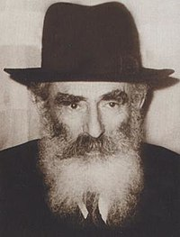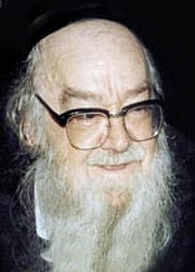
Rabbi Yechezkel Levenstein Rabbi Shalom Schwadron

Reb Shalom Schwadron, zt’l, once saw Reb Yechezkel Levenstein, zt’l, in an aura of immense joy, and he asked him about it.
Reb Yechezkel said, “When I was the mashgiach of yeshivas Mir (Lithuania) the paycheck didn’t always come on time, thus I was forced to place my trust in Hashem.
“When I came to Eretz Yisrael, Rav Yosef Shlomo Kahaneman offered me the position of mashgiach in the Ponevezh yeshiva. I was happy with his offer, because I naively thought that the Ponevezher Rav has a lot of money, and my paycheck would finally come on time.
“I was only worried about my bitachon. Because when I was in Mir, I had a constant reminder to trust in Hashem, but how would I have bitachon in Ponevezh, when I’m earning a comfortable living?
“I’ve been in the yeshiva for eight months now, and I see that here too, money doesn’t come on time. I have to trust in Hashem once again, and therefore I’m so joyous.”

Reprinted from the Parshas Terumah 5779 email of Torah Wellsprings: Collected Thoughts from Rabbi Elimelech Biderman.
The Legacy of Nosson
The Lowly Sinner

Rabbeinu Nisim Gaon (quoted in Seder HaDoros, Tana'im and Amaro'im, letter Nun) tells the following story: There was a lowly, sinful man called Nosson. Once, he had the opportunity to commit a terrible sin, but he controlled himself.
A few days later, Rabbi Akiva saw him riding a donkey. Rabbi Akiva perceived that Nosson's face was shining like the midday sun, and an aura was glowing above his head.
Rabbi Akiva asked his students, "Who is that man?"
"It’s Nosson, the lowly sinner."
"Do you see anything above his head?"
"No. We don’t see anything."
"Bring him to me, quickly."
Rabbi Akiva said to Nosson, "My son, an aura of light is glowing on top of your head, so I know that you will merit Olam HaBa. Tell me what great deed did you do?"
Nosson told him that he didn't give in to his temptations and held back from transgressing a grave sin. He was a 'serial' sinner, and had committed many similar sins before, but this time he controlled himself.
Reb Akiva was stunned that Nosson had the willpower.
"Indeed, you did a great deed, and Hashem therefore gave you an aura of light above your head. This is in this world. In the next world, you will certainly become much holier and greater because of this good deed. Now, my son, listen to me. Sit before me, and I will teach you a lot of Torah."
Nosson became Rabbi Akiva’s student. His heart was open for Torah, and within a short time, he became a great scholar, the holy tana, Reb Nosson Tzutzisa, brought down in Chazal.
This amazing story teaches us the good one can earn by overcoming his challenges. Nosson changed from being a great sinner to becoming a holy tana. By the same token, we must know that with every test we pass, we grow extremely great.

Reprinted from the Parshas Terumah 5779 email of Torah Wellsprings: Collected Thoughts from Rabbi Elimelech Biderman.

The Comeback Kid

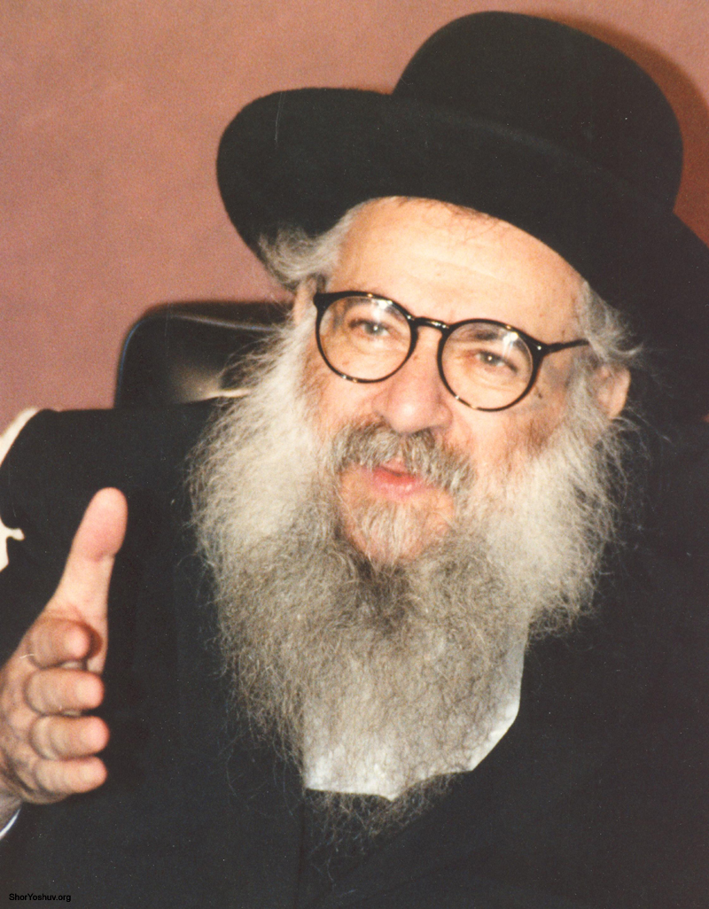
Rabbi Shlomo Freifeld

One of the unfortunate victims of the social upheaval of the 1960's was young Moshe Kleinberg (not his real name). Moshe attended the finest yeshivas in Europe.
However, Moshe got caught up in the times and eventually left yeshiva. Once out of yeshiva, young Moshe began to slip in his mitzvah observance. The yarmulke came off, the hair grew long, Shabbos was desecrated... in a short time, Moshe became a totally secular Jew. Moshe had gone off the way of Hashem.
Moshe wandered around Europe searching for meaning. Eventually, Moshe found himself in America. Soon after arriving in America, Moshe ran out of money. He had nothing to eat and he became desperate to get a job to feed himself. One day, Moshe picked up a newspaper and saw an advertisement which caught his eye. A yeshiva in the area was looking for a janitor. The thought of stepping foot inside a yeshiva again was a little difficult for Moshe. It had been several years since Moshe had left Yiddishkeit. However, at this point he was literally starving, so he would try anything for money.
So, a little while later, Moshe walked into the yeshiva of Reb Shlomo Freifeld, of blessed memory and applied for the job of janitor. Reb Shlomo greeted Moshe warmly and the two sat down together to speak about the position. Reb Shlomo was not surprised by the raggedy appearance which Moshe presented. In those days, all types came to learn at the yeshiva of Reb Shlomo.
However, Reb Shlomo sensed that there was something different about Moshe, he was no ordinary candidate for the job of janitor. Reb Shlomo could see into the soul of Moshe; the light was faint, but it was definitely still burning. Reb Shlomo instinctively began to ask Moshe about his background and schooling. Soons, Reb Shlomo found out what he had suspected from the very beginning: Moshe came from a religious background and had attended the finest yeshivas in Europe.
Reb Shlomo then surprised Moshe by offering the long haired young man a position as Magid Shiur.
Moshe was shocked! "Me, a Magid Shiur? I have long hair. I am not religious. I have not learned for so long."
Reb Shlomo would not take "no" for an answer. Moshe had learned for several years in yeshiva, surely he was qualified. And besides, Moshe was hungry and needed a job. Moshe agreed to show up a couple of days later to begin giving a shiur in Bava Metzia.
There was little time to prepare for the lesson, so Moshe hurried to begin learning again. Moshe got a hold of a Bava Metzia and began preparing for the lesson.
Moshe thought it would be funny for him to show up for the first day of work without a yarmulke, so, Moshe went out and got a yarmulke. The first day went well enough, the three students asked questions and Moshe seemed to really understand the learning.
Soon after, Moshe approached the Rosh Yeshiva Reb Shlomo and told him that he felt bad that he was not wearing tzitzis.
"So get a pair of tzitzis" said Reb Shlomo.
Sure enough, Moshe went out and bought a pair of tzitzis and began wearing them all the time. Eventually, Moshe felt ashamed of his long hair and so he got a more appropriate haircut for a Jewish young man. Slowly but surely, Moshe began to take on more and more mitzvahs. Shabbos, tefillin and kosher eating became a part of his life again after so many years of being away from Hashem.
Today, Moshe is a fully observant Jew with a large family with several Orthodox grandchildren. Moshe and the world will forever be thankful to Reb Shlomo Freifeld, who gave a young long haired man a second chance.
Reb Shlomo saw a spark in Moshe. The long hair and the messy appearance of Moshe did not fool Reb Shlomo. Reb Shlomo felt that Moshe had potential in his soul. Reb Shlomo was right. (heard from Reb Ephroim Wachsman who heard it from Reb Nosson Deutsch)

Reprinted from the Parshat Mishpatim 5779 email of Good Shabbos Everyone.
Definition of a Masmid

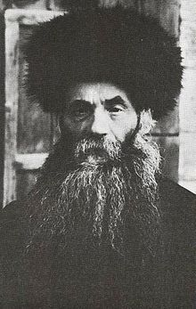

When Rav Zundel Kroizer, zt”l, was young, he learned in Yeshivas Eitz Chaim, and the Rosh HaYeshivah was Rav Isser Zalman Meltzer, zt”l. During one of his talks with the boys about being a Masmid, one who is studious and serious about his learning, and how they should all strive for this, Rav Isser Zalman asked them, “What is the definition of a Masmid, in your minds?”
One of the students said that it is someone who learns ten hours a day, and less than this would not be considered a Masmid. But Rav Isser Zalman deflected this answer and said that this would still not be a Masmid.
The other students realized that ten hours of learning a day was too low to be a Masmid, since that is less than half of the twenty-four hours that are in a day, so they each tried to increase the number of hours. One said twelve hours, another said fourteen hours, a third one said sixteen hours, and then a fourth boy raised it to eighteen hours, but to their surprise, this still did not satisfy the Rosh HaYeshivah.
The students said to him, “If this is not enough, Rebbe, please tell us, what is a Masmid?”
Rav Isser Zalman said to them, “You are correct that a Masmid dedicates his time to learning Torah, however, just because a person sets aside time for Torah, this does not make him a Masmid! It is possible that someone has no distractions that prevent him from learning, therefore, he sets aside time to learn Torah. It does not make him a Masmid just because he simply has the time available to learn.
“If so, then when does he become a Masmid? One can become a Masmid when he shows that he learns, even when he is surrounded by distractions! The one who is a Masmid is constantly involved in Torah.
“But if one lets his distractions get to him and he closes his Sefer, then he is showing that he is not a Masmid, because he will only think about Hashem’s Torah and learning if it comes easy to him. The main idea is that it is not just the quantity of learning, but it is the quality of learning. One who learns even when it is difficult for him, is truly considered to be a Masmid!”

Reprinted from the Parshas Terumah 5779 email of Torah U’Tefilah compiled by Rabbi Yehuda Winzelberg.

Thoughts that Count
For Parashat Tetzave

Command the Children of Israel that they bring you pure olive oil, pounded, for the lighting, to cause a light to burn always (Ex. 27:20)
The First and Second Holy Temples illuminated the world with their light for a specific and limited period of time. The Third Holy Temple, however, which will be rebuilt when Moshiach comes, will be in fulfillment of the latter half of the verse, "to cause a light to burn always." Its light will never be extinguished. (Rabbi Yitzchak Karo)

You shall command--ve'ata tetzave (Ex. 27:30)
Chasidic thought interprets this verse to mean, "You shall connect yourself to..." Moses was commanded to establish a connection between his essence and the Jewish people. In an extended sense, this command can be understood as having been directed to every Jew, for each Jew has a spark of Moses in him. "You" refers to the essence of the soul, the fundamental core of every Jew's being. This is revealed by the establishment of a bond with G-d's essence. (Lubavitcher Rebbe, shlita)

Reprinted from the Parashat Tetzave (Issue #256 1992/5753) edition of L’Chaim Weekly.

